# **Group Project** – **Report on Inventory Management System for Global Retailers Inc.**

**Group – 2**

**Gowri Rohith chirra (U00904650)**

**Rohith Reddy Garlapati (U00904490)**

**MIS-7610-002 System Analysis & Design Fall Term 2023**

**Professor: Robert Rose**

# Report on Inventory Management System for Global Retailers Inc.

# *Industry and Organization Background information*

Industry Overview:

Retailing is a very dynamic world with respect to changing consumer demands and a lot of competition. Global Retailers Inc. plays around in such an environment where they sell variety of products from electronics to clothes to homeware appliances. Supported with traditional stores well complemented by a broadening online retailing domain, the company envisages effectively reorienting its operations so as to remain parallel to modern day trends and customer expectations.

Organizational Profile:

Global Retailers Inc. is a large scale of retailing Conglomerate synonymous with ensuring its Customers access varieties of products of superior quality. The organization realizes the need to have an all-encompassing Inventory Management System that will facilitate controlling and managing inventory for multi-locations.

# *Planning Phase*

## Organizational Information:

The famous retail behemoth Global Retailers, Inc. operates in both the physical and digital marketplaces. The organization strives to fulfill the changing demands and tastes of its clients by offering a wide variety of products. Modernizing inventory control and management procedures is a top priority for the company, which is why they are investing in an advanced Inventory Management System (IMS).

## Goals:

One well-known retail giant that has a foot in both the brick-and-mortar and virtual worlds is Global Retailers, Inc. The organization strives to fulfill the changing demands and tastes of its clients by offering a wide variety of products. Modernizing inventory control and management procedures is a top priority for the company, which is why they are investing in an advanced Inventory Management System (IMS).

## Alignment with Organizational Strategy:

By fixing the most pressing problems with stock management, the IMS project supports the overall business plan. Reducing carrying costs, enhancing stock count accuracy, and establishing a smooth and effective inventory management system across all sites are all aims that this helps to.

## Value Addition:

1. Standardizing stock-taking methods.
2. Enhancing the accuracy of stock counts.
3. Automating reorder processes for better inventory control.
4. Improving vendor management through the administration of third-party resources.
5. Providing analytical reporting for informed decision-making.

## Goals/Project Identification

**"As Is" System:**

Due to its reliance on manual procedures, Global Retailers Inc.'s existing inventory management system is inefficient and prone to mistakes. There are delays and the possibility of stock outs since reorder operations are not automated and stock levels are maintained manually. The organization's inventory levels cannot be seen in real-time due to the absence of a centralized system.

**Current Problem:**

Problems with the current system originate from its lack of accuracy, inefficiency, and capacity to adjust to the increasing complexity of processes. Because of these problems, carrying costs go up, order processing takes longer, and customers can be unhappy.

**Three Alternatives for the New System:**

1. Implementing a comprehensive Inventory Management System (IMS).
2. Upgrading the existing system with automation features.
3. Outsourcing inventory management to a third-party provider.

**Feasibility Study (Technical, Economic, Organizational):**

**Technical Feasibility:** The IMS is technically feasible, leveraging modern technologies for real-time monitoring, automation, and integration with existing systems.

**Economic Feasibility:** The project is economically viable, with a positive return on investment expected through reduced carrying costs and improved operational efficiency.

**Organizational Feasibility:** The organization is ready for this change, with support from key stakeholders and a dedicated project team in place.

# *Project Selection and Management*

## Baseline Project Report (Ongoing Details of Project with Reports and Diagrams)

**Project Plan (Managing and Controlling the Project):**

The project plan serves as a comprehensive guide for managing and controlling the IMS implementation project at Global Retailers Inc. It includes:

**Deadlines/Milestones:**

* Project Initiation and Requirements Gathering: 10 days
* Design and Architecture Planning: 12 days
* Development and Coding: 20 days
* Testing and Quality Assurance: 8 days
* Deployment and Training: 6 days
* Post-Implementation Support and Fine-Tuning: 10 days

**Individual Assignment (Role):**

* Rohith Reddy Garlapati was Responsible for overall project coordination, planning, and execution and engaged in coding and system development.
* Gowri Rohith Chirra had the Analyzing requirements and ensuring system alignment with organizational needs and was responsible for testing and ensuring system quality and took the Experts in Managing Databases and Overseeing database-related aspects of the project.

**Gantt Chart**

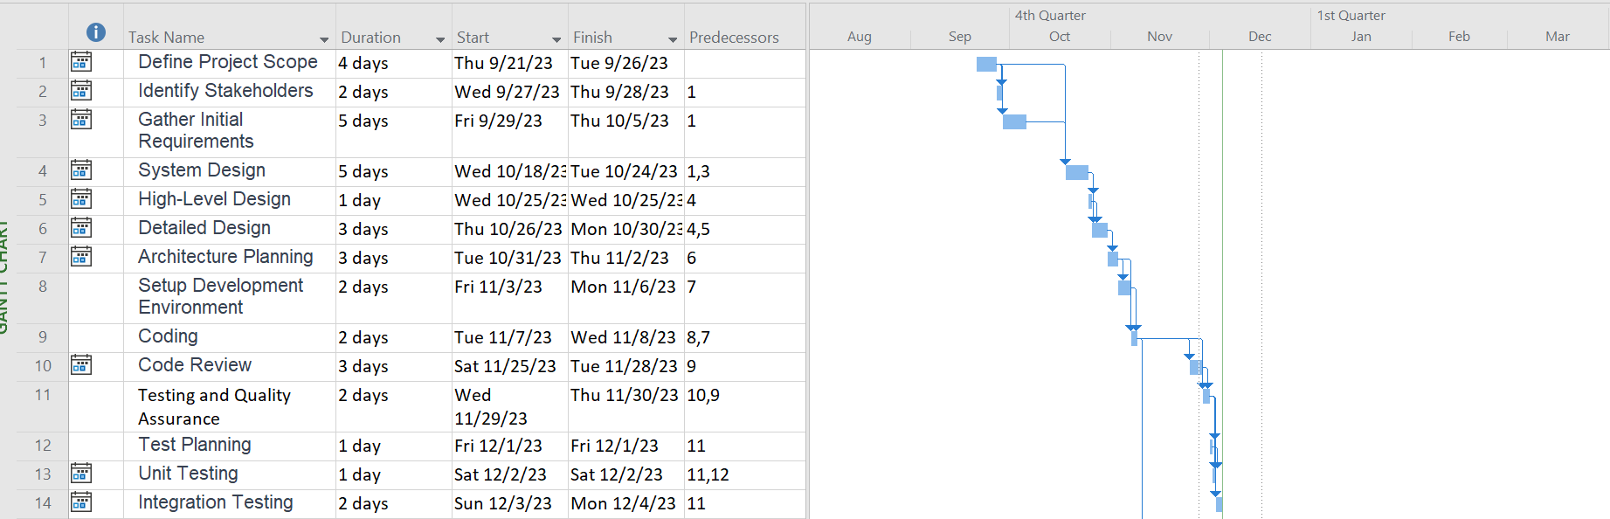

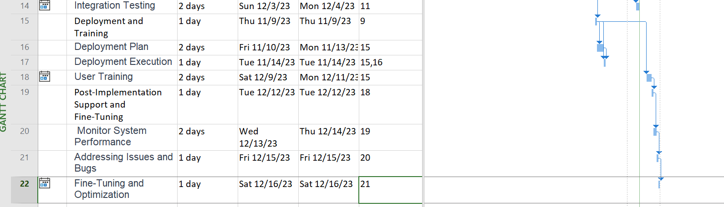

**Network Diagram**

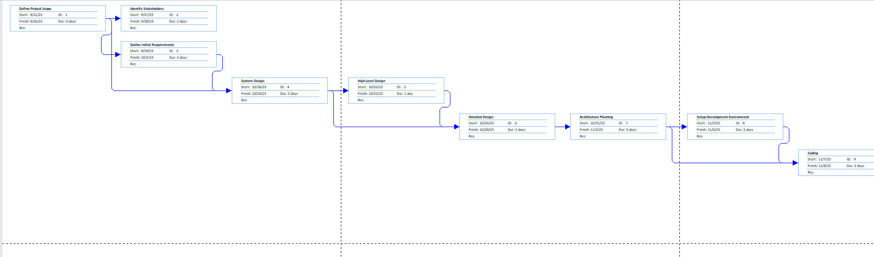

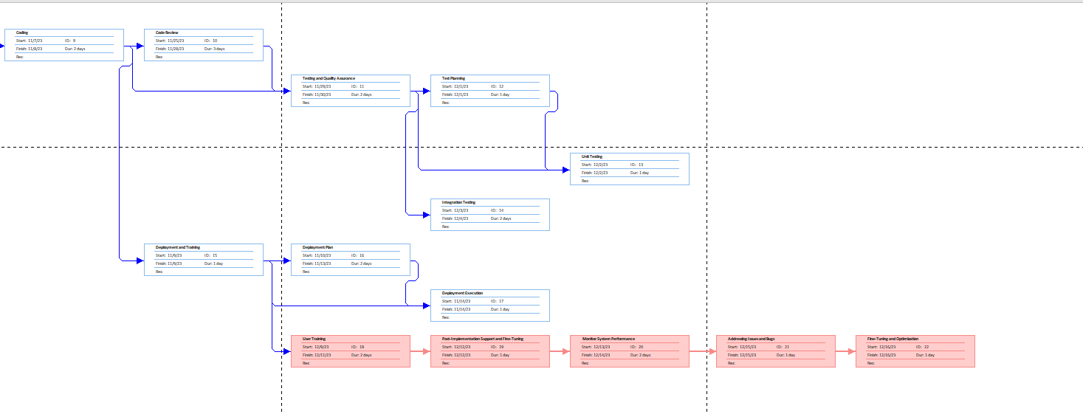

**Project Team Communication Plan:**

## Project Scope:

* Clearly defined project scope focusing on implementing the Inventory Management System (IMS).
* Regular scope review to ensure alignment with organizational goals.

**Communication Channels:**

* Weekly team meetings to discuss progress, challenges, and upcoming tasks.
* Bi-weekly progress reports distributed to all team members.
* Immediate communication through a dedicated project management platform for urgent matters.
* Monthly project status updates are presented to key stakeholders.

**Issue Resolution:**

* Dedicated channels for issue reporting.
* Weekly issue resolution meetings to address challenges promptly.

**Change Management:**

* A formalized change request process to manage alterations to the project scope.
* Change impact assessments are conducted before implementing any modifications.

**Documentation:**

* Centralized document repository for easy access to project-related documents.
* Regular documentation audits to ensure accuracy and completeness.

# *Requirements Determination*

**Requirements Analysis Techniques:**

1. Interviews:

* Interviewing IT staff, warehouse employees, and important stakeholders.
* Acquiring knowledge about the shortcomings of the present inventory management system as well as expectations for it.

1. Document Analysis:

* Extracting valuable information to understand the intricacies of the current system and identify areas for improvement.

1. Observation:

* Observing the day-to-day activities of shop managers and warehouse staff involved in inventory management.
* Identifying manual processes, bottlenecks, and areas where automation can enhance efficiency.

1. Surveys/Questionnaires:

* Analyzing survey responses to identify common themes and issues.

1. Prototyping:

* Developing prototype interfaces for the Inventory Management System and gathering feedback from potential users.
* Iteratively refining the system design based on user feedback to ensure alignment with user expectations.

**Requirements Gathering Techniques:**

1. Notes:

* Documenting key points, observations, and stakeholder comments during interviews and observation sessions.
* Compiling comprehensive notes to serve as a reference for understanding user needs and expectations.

1. Questionnaires:

* Developing targeted questionnaires to gather specific information from a broader audience.
* Structuring questions to elicit detailed responses about present procedures, difficulties, and desired functionalities.

1. Interview Transcripts:

* Creating detailed transcripts of interview sessions with stakeholders.
* Ensuring accuracy in capturing verbal expressions of requirements, concerns, and suggestions.

1. Storyboards:

* Developing visual storyboards to illustrate how users envision interacting with the Inventory Management System.
* Using storyboards to identify user preferences and requirements for the system's user interface.

**Requirements Documentation:**

1. Functional Requirements:

* Clearly outlining the system's functionalities, such as real-time stock monitoring, automated reorder notifications, and vendor management.

1. Non-functional Requirements:

* Documenting non-functional needs, including subsystem performance, safety, and scalability.

1. User Stories:

* Creating user stories to describe specific tasks or interactions users expect from the system.
* Linking user stories to functional requirements for comprehensive coverage.

1. Use Cases:

* Developing use cases to depict system interactions in various scenarios.
* Ensuring that use cases cover a range of user roles and system functionalities.

1. Data Requirements:

* Clearly specifying data needs, storage specifications, & data flow within the Inventory Management System.

# *Use Case Analysis*

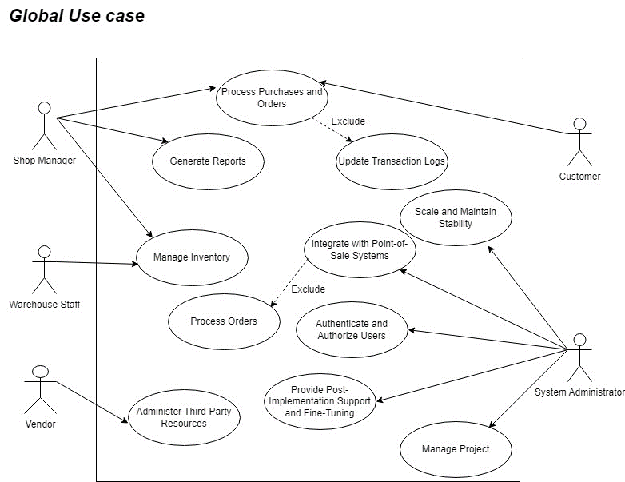

# *Process Modeling Diagrams (DFDs)*

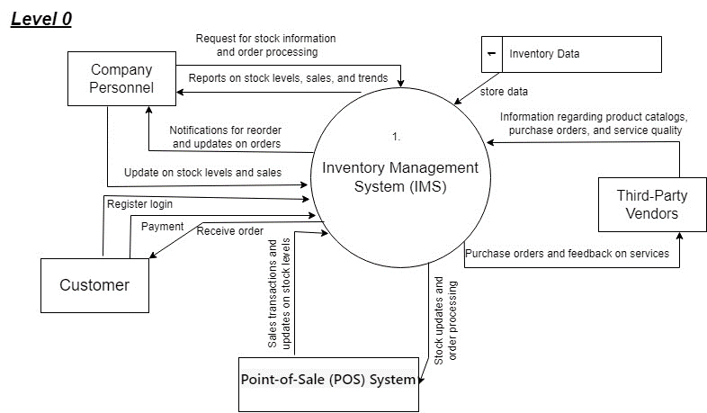

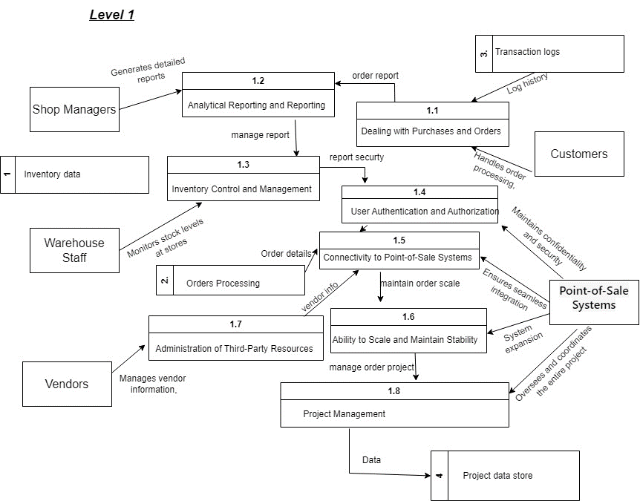

# *Data Modeling (ERDs)*

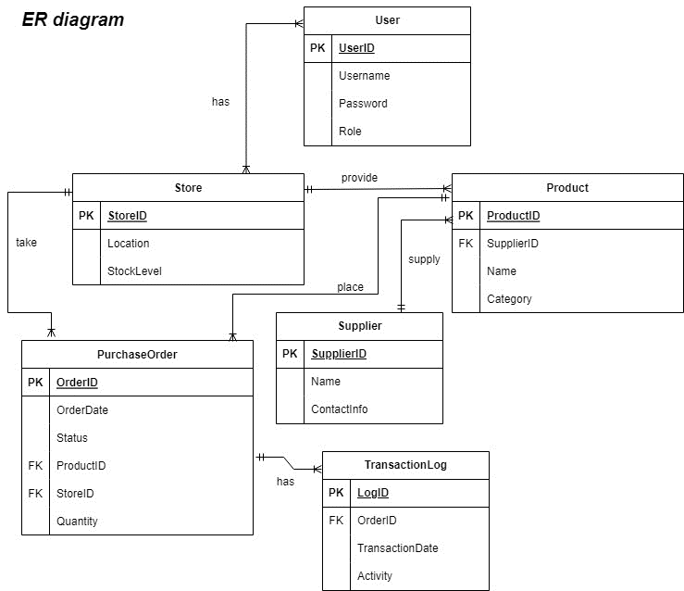

# *8. Design Acquisition Strategy*

## Description of Acquisition Strategy:

Global Retailers Inc. has formulated a comprehensive acquisition strategy for the creation and enhancement of its Inventory Management System (IMS). The approach integrates both internal development capabilities and external outsourcing to optimize the utilization of in-house expertise while leveraging external resources for specialized skills and operational efficiency.

**In-House Development:**

The core system architecture, database design, and integration with existing systems will be developed in-house. This allows for better alignment with organizational goals, seamless integration with current processes, and improved control over the development process.

**Outsourcing:**

Certain aspects of the project, for instance, the customer interface design, may be outsourced to specialized design and development firms. This enables the project team to advantage from external expertise in user experience (UX) and interface design, ensuring the IMS is user-friendly and meets modern design standards.

## Alternative Matrix:

|  |  |  |
| --- | --- | --- |
| Criteria | In-House Development | Outsourcing |
| Control | High | Moderate |
| Expertise Required | Internal expertise | External UX/UI expertise |
| Integration with Existing Systems | Seamless integration | Coordination required |
| Development Speed | May take longer | Faster turnaround |
| Cost | Potentially higher | Cost-effective, depending on contract terms |
| Risk Management | Easier to manage risks with direct control | Dependent on outsourced vendor performance |
| Flexibility | Highly flexible | Limited by outsourcing agreement terms |

**Decision Rationale:**

* When a project is developed in-house, we have more say over how it fits into the overall strategy of the company and how it interacts with other systems.
* The IMS benefits from the specialist knowledge in user interface design and user experience that may be attained via outsourcing some design activities.
* When essential outside knowledge is lacking, development times may be significantly reduced by outsourcing certain components. A more adaptable strategy may be used to accommodate project deadlines.
* Risk Management vs developing in-house, which gives you superior control over risk management, outsourcing makes you dependent on other providers. But these dangers may be reduced with vigilant vendor monitoring and judicious selection.
* The pricing issue is well-rounded; in-house development may be more expensive but gives you more control, while outsourcing might save you money, particularly for specialized jobs.

# *Architecture Design*

**Architecture Specification Documents:**

Global Retailers, Inc.'s Inventory Management System (IMS) is described in great length in the Architecture Specification Documents. All the necessary parts, modules, interfaces, and technologies that will be used to complete the project are detailed in the documentation.

1. System Architecture:

**Description:** The general architecture of the IMS, describing the high-level elements and how they work together.

**Components:**

* Front-end (User Interface)
* Back-end (Server, Database)
* Integration with Point-of-Sale (POS) Systems
* External API Integrations

**Technologies:**

* Front-end: HTML5, CSS3, JavaScript (React for dynamic user interfaces)
* Back-end: Node.js (Express framework)
* Database: SQL (e.g., PostgreSQL)
* Integration: RESTful APIs

1. Database Design:

**Description:** The structure and organization of the database to efficiently store and retrieve inventory data.

**Entities:**

* Products
* Stock Levels
* Purchase Orders
* User Authentication

**Relationships:**

* One-to-Many relationships between Products and Stock Levels
* Many-to-One Relationship between Purchase Orders and Products

**Database Management System (DBMS):** PostgreSQL

1. User Interface (UI) Design:

**Description:** The design principles and layout of the user interface for efficient user interaction.

**Components:**

* Dashboard with real-time stock updates
* Product catalog and classification
* Order processing and status tracking
* User authentication and authorization

**Design Principles:**

* Intuitive navigation
* Responsive design for various devices
* Minimalist and user-friendly interfaces

**Tools:**

* UXPin for prototyping
* Adobe XD for design mockups

1. Integration with Point-of-Sale (POS) Systems:

**Description:** Ensuring seamless communication between the IMS and existing POS systems.

**Protocols:**

* Integration using RESTful APIs
* Data synchronization in real-time

**Error Handling:**

* Robust error-handling mechanisms to manage discrepancies

1. Security Architecture:

**Description:** Ensuring the confidentiality, integrity, and availability of sensitive inventory data.

**Authentication:**

* Role-based access control (RBAC)
* Secure user authentication using encrypted credentials

**Authorization:**

* Access permissions based on user roles
* Encrypted communication (HTTPS) for data transmission

1. Scalability and Performance:

**Description:** Design considerations for system scalability to accommodate future growth.

**Load Balancing:**

* Implementing load balancing for even distribution of user requests

**Caching Mechanisms:**

* Employing caching strategies for frequently accessed data

**Monitoring:**

* Integration with monitoring tools for performance analysis

1. Disaster Recovery and Backup:

**Description:** Strategies for data backup and recovery in case of system failures or data loss.

**Backup Frequency:**

* Regular automated backups of the database

**Recovery Procedures:**

* Documentation of recovery procedures
* Regular testing of recovery mechanisms

To guarantee a methodical and well-documented approach to constructing the Inventory Management System, the development team may refer to these Architecture Specification Documents for a complete guidance. All stakeholders and team members may refer to the papers as a resource throughout the development lifecycle.

# *User Interface Design*

# 

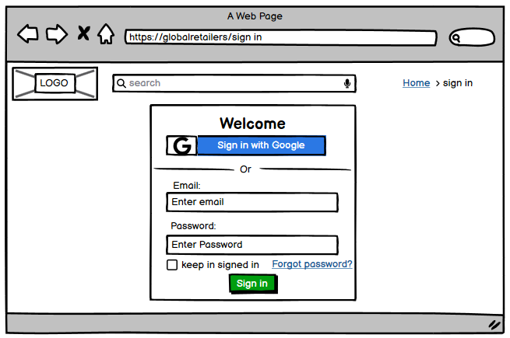

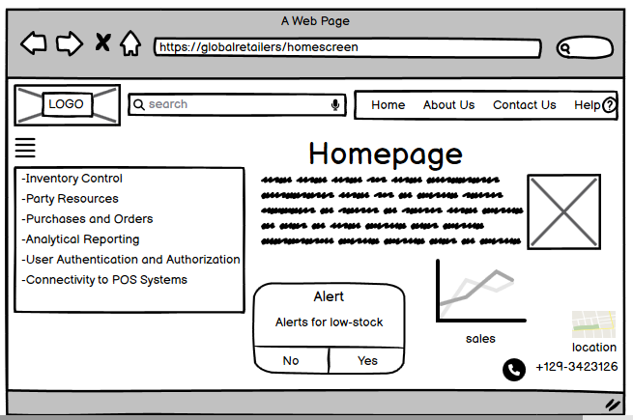

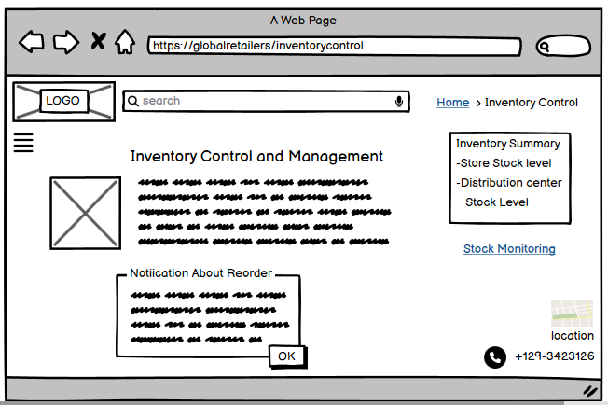

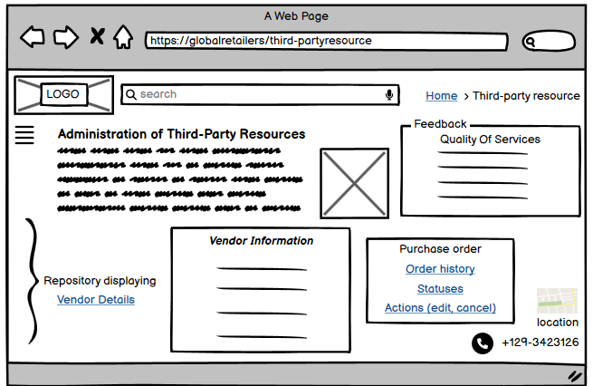

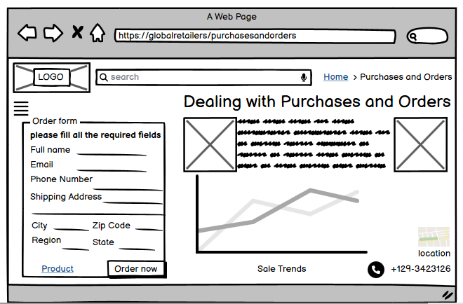

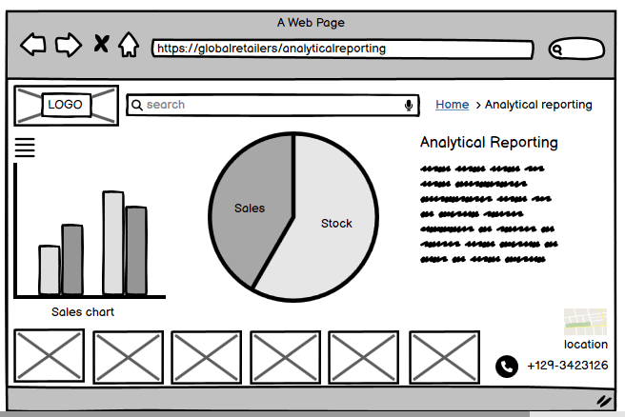

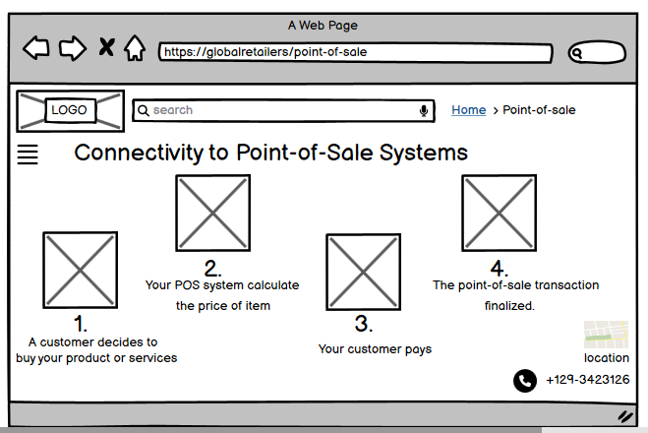

# *Data Storage Design*

## Description of Data Design Plan:

The data design plan stands as an explanation for the architecture and organization of the storage system of revised data for an Inventory Management System (IMS) in Global Retailers Inc. This covers database design, entities involved in the design concerning relationships, and ways that can be applied to effectiveness in data access and manipulation handling.

1. Entity-Relationship Diagram (ERDs):

In terms of visual display, an ERD looks like a schema over the database, describing all the vital entities, attributes and relations throughout the system model.

* Entities include:
* Products
* Stock Levels
* Purchase Orders
* Users (for authentication and authorization purposes)
* Relations define how entities relate, for example Products and Stock Levels.

2. Normalization:

* + A data design plan involves numerous normalization techniques that remove redundancy on data and ensure good data integrity.
  + The normalized positioned entities of tables eliminate data anomalies and ensure good handling of the data storage.

3. Database Management System (DBMS):

* + The IMS project has the use of PostgreSQL DBMS.
  + PostgreSQL is a relational database management supporting and providing a firm platform to process the structured data that are important in inventory management.

4. Data Integrity Constraints:

* + The integrity constraints will be defined as part of designing the data plan for ensuring the exactness as well as consistency of data.
  + Primary keys, unique constraints, foreign keys, and check constraints are enforcement mechanisms to maintain data quality.

5. Data Storage Strategies:

* + Retrieval speed optimization and storage space optimization provoke each system fervently in search of smart effective storage space for the data.
  + The database references serve to store huge data sets like the images of the products in an efficient way without bloating the size of the database.

1. Indexing:

* Indexing is employed to enhance data retrieval performance.
* Key fields, such as product IDs and user IDs, are indexed to facilitate quicker query execution.

1. Data Security:

* Data security measures include encrypted storage for sensitive information, such as user credentials.
* Role-based access control (RBAC) is implemented to ensure that users only access data relevant to their roles.

1. Backup and Recovery:

* Regular automated backups of the database are scheduled to prevent data loss in case of system failures.
* Detailed recovery procedures are documented and tested to ensure a swift recovery process.

## How ERDs Support the Plan:

The Entity-Relationship Diagram (ERD) plays a crucial role in supporting the data design plan:

1. Visual Representation:

* The ERD provides a clear visual representation of the database schema, allowing stakeholders to understand the structure of the data.

1. Relationships:

* ERDs explicitly show the relationships between entities, guiding the establishment of foreign key relationships in the database. For instance, the relationship between Products and Stock Levels is represented in the ERD.

1. Normalization:

* The ERD aids in the normalization process by illustrating the entities and their attributes. Normalization decisions are informed by the relationships depicted in the ERD.

1. Data Integrity:

* Integrity constraints, derived from the ERD, ensure that data is accurately and consistently stored. Primary keys, foreign keys, and other constraints are visualized in the ERD.

1. Collaboration:

* The ERD serves as a communication tool between database designers, developers, and stakeholders, fostering collaboration and a shared understanding of the data model.

# *Implementation & Transition Plan*

## Implementation Plan:

**Description of How You Plan to Implement:**

1. System Development:

* In-house development of the IMS components, including front-end, back-end, and database, based on the architecture and design specifications.

1. Testing and Quality Assurance:

* Rigorous testing of the IMS to identify & rectify any bugs or problems.
* Conducting user acceptance testing (UAT) to ensure the system meets stakeholder expectations.

1. Deployment:

* Gradual deployment across select locations to minimize operational disruption.
* Monitoring system performance and addressing any issues that arise during the initial rollout.

1. Training:

* Conducting training sessions for shop managers, warehouse staff, and other relevant personnel to familiarize them with the new system.
* Providing training materials and resources for ongoing reference.

1. Integration with POS Systems:

* Ensuring seamless integration with Point-of-Sale (POS) systems to maintain consistency in transaction records.
* Conducting thorough testing of the integration to identify and resolve any discrepancies.

1. User Authentication Setup:

* Configuring user authentication and access control based on predefined roles.
* Verifying that user roles align with organizational requirements for confidentiality and security.

1. Communication and Change Management:

* Establishing effective communication channels to keep stakeholders informed throughout the implementation process.
* Implementing change management strategies to address resistance and ensure a positive reception of the new system.

## Transition Plan:

Migration Plan, Training, Motivating Employees, etc.:

1. Migration Plan:

* Gradual migration from the old system to the new IMS to minimize disruptions.
* A rollback plan in case of unforeseen issues during the initial stages of deployment.

1. Training:

* Conducting comprehensive training sessions for all users, focusing on the features and functionalities of the IMS.
* Providing hands-on training to ensure practical understanding and proficiency.

1. Motivating Employees:

* Recognizing and celebrating milestones during the implementation to boost morale.
* Communicating the benefits of the new system, emphasizing how it will improve daily tasks and overall efficiency.

1. User Support:

* Establishing a dedicated support system to address user queries and issues promptly.
* Providing ongoing support during the initial weeks to facilitate a smooth transition.

1. Feedback Mechanism:

* Implementing a feedback mechanism to gather input from users during the early stages of implementation.
* Using feedback to address concerns and make necessary adjustments.

## Forecast for Maintenance:

1. Growth/Flexibility:

* Designing the IMS with scalability in mind to accommodate future business growth.
* Regularly updating and enhancing the system based on evolving business needs.

1. Budget:

* Allocating budget for ongoing maintenance, updates, and potential system enhancements.
* Periodic reviews of the budget to ensure alignment with project goals and organizational priorities.

1. Future Issues/Problems:

* Establishing a proactive approach to identify and address potential issues.
* Regular system audits and performance reviews to identify areas for improvement.

1. Continuous Improvement:

* Implementing a continuous improvement plan to enhance system efficiency and address emerging challenges.
* Regularly seeking user feedback to identify areas for optimization.